Creating a Database and Table in MySQL in
Azure SOP



Table of Contents

1. Creating a Database and Table in MySQL in Azure 3
1.1 Description 3
1.2 Architecture Diagram 3
1.3 Lab Steps 4
1.4 Supporting References 5

Creating a Database and Table in MySQL in Azure

Description
MySQL is a standard Database application that can be run on both Windows and Linux. This SOP will introduce you to installation steps of MySQL and creating and database and table.

Architecture Diagram
The diagram below displays a visual representation of the underlying application architecture:
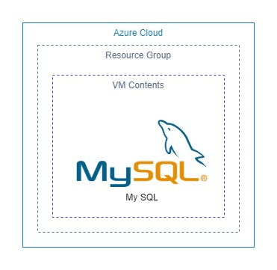

Lab Steps
Follow the steps outlined below to achieve the objective of this lab exercise:

- Create an Azure VM:
  - Resource Group: <Your Resource Group>
  - VM Name: <some name>
  - Image: Ubuntu Server 18.04 LTS
  - Azure Spot Instance: No
  - Size: Standard DS1 v2
  - Authentication Type: Password
  - Username: <specify a username>
  - Password: <specify a password>
  - Confirm Password: <re-enter the password>
  - Review and Create.
- SSH into the VM using Cloud Shell option. (Located adjacent to the search bar at the top):
  - If it says “You have no storage mounted”, follow the below steps. If not, proceed with next steps. b. Select Show Advanced Settings.
  - Leave the already filled in fields to their default values.
  - Storage Account: <any name> [Create New Option]
  - File Share: <any name> [Create New Option]
- Once the Terminal is displayed, change the shell to Bash (option can be found at the top left of the terminal window).
- Give the following command to SSH into the VM:
ssh ubuntu@<Public IP of the VM>
  - Enter the password created while creating the VM.
- Once SSH is complete, follow the below steps:
  - Change to Super User or Root User
  - Change directory to “~”
  - Update VM with the following command:
apt update && apt upgrade
  - Install MySQL using the following command:
apt install mysql-server
- Now that the installation is done, in order to create Database and Tables, follow the below commands:
  - Enter mysql. This will change the terminal to mysql command prompt, which allows you to execute SQL Commands.
  - Create a Database:
CREATE DATABASE <your database name>;
  - List the Databases created:
SHOW DATABASES;
  - Use the created Database:
USE <db name>;

  - Create a table:
CREATE TABLE sample (name VARCHAR(20), age INTEGER);

Supporting References
Refer the below link for additional information:

- https://www.digitalocean.com/community/tutorials/how-to-install-mysql-on-ubuntu-18-04

